Secondhand Lens Pte Ltd
Software Architecture Proposal
6th June 2018

Certis Technology (Singapore) Pte Ltd
20 Jalan Afifi
Certis CISCO Centre
Singapore 409179

Eric See Kian Seng
Solution Architect
Tel: 90308495
Email: ericks_see@certissecurity.com

This document is Certis Technology (Singapore) Pte Ltd’s proposal to SMRT. It is intended solely for the named organisation and shall be used strictly for such purpose only. All information in this document must be kept strictly confidential. This document shall not be used or referred to, in whole or in part, or quoted by excerpt or reference in any manner, and shall not be circulated to any third party without the prior written approval from Certis Technology (Singapore) Pte Ltd.

BRIEF CORPORATE PROFILE

Certis CISCO – Singapore’s Most Comprehensive Security Solutions Provider
Headquartered in Singapore, Certis CISCO is the largest and most comprehensive security solutions provider. The Certis Group is a wholly-owned subsidiary of Temasek Holdings, an investment arm of the Singapore Government.

With over 50 years of experience and proven track record in protecting lives and assets, our wide scope of security services and products include – armed auxiliary police officers; unarmed security officers; secure logistics; cash-in-transit and cash processing; smartcard bureau services; aviation security; enforcement services; security consulting and training; security technology; defence services; business process outsourcing; technology services; and IT security and information management.

The Certis Group has also established footprints in China, Hong Kong, Macau, Indonesia, Malaysia, Sri Lanka and the United Arab Emirates. Commanding a workforce of over 28,000 officers worldwide, Certis CISCO is the experienced partner of choice for all security, manpower and technology needs. Certis CISCO’s close partnership with the Singapore government and its multiple agencies has proven its continued ability to ensure win-win partnerships of success in its provision of all manpower and services for state-wide needs.


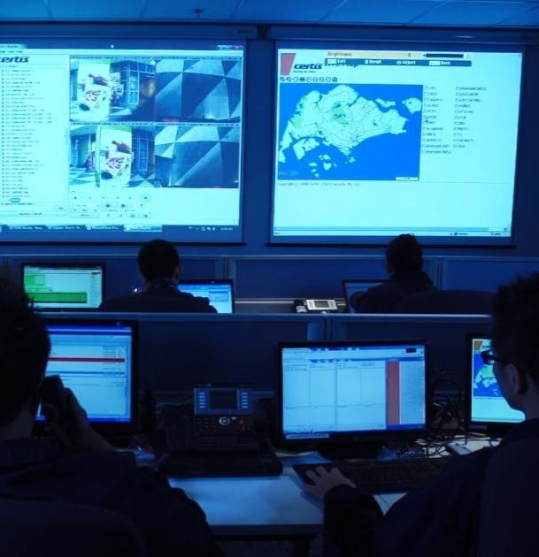


Contents
1. Background 7
2. What’s Next 7
2.1. Current Challenges 7
2.2. Proposed Solution Scope of Work 8
2.3. Certis Approach 8
3. Main BOCC Platform Solution 10
3.1. Overall Solution Architecture 10
3.2. Software Architecture 15
3.2.1. Technologies & Tools 15
3.2.2. APIs 17
4. Solution Highlights 18
4.1.1. Interchange Technologies 18
4.1.2. Bodyworn & PTT Radio 20
4.1.3. Videowall Solution 21
4.1.4. Cisco Video Conferencing Solution 24
4.1.5. Ironyun Video & AI Management 26
5. ELogs 28
5.1.1. User & Groups Login Credentials 28
5.1.2. Administration & Operational Dashboard 29
5.1.3. BIMP Classifications 30
5.1.4. Operational Reports 31
5.1.4.1. Critical Events Log 31
5.1.4.2. ECLO (Early Closure Late Opening) 32
5.1.4.3. Bridging Form 33
5.1.4.4. FLBP Form 34
5.1.4.5. OTA Form 35
5.1.4.6. Break Down Form 36
5.1.4.7. Service Recovery Form 36
5.1.4.8. EWT Form 37
5.1.4.9. Incidents & Accidents Form 37
5.1.5. Incident & Accident Flow between Main BOCC and Zone BOCC 38
5.1.5.1. Incidents/Accidents Reporting Flow 38
5.1.5.2. Non-Incidents & Accidents Reporting Flow 39
5.1.6. Reports 39
6. Assumptions & Constraints 40
7. Certis Value Added Services 41
5.1 Physical Security Services 41
5.2 Human Resource Services 41
5.3 Integrated Facilities Management 42
5.4 Cyber Security Services 42
8. Appendix 43

Figures
Figure 1 Certis IOT Digital Framework 9
Figure 2 Certis BOCC Digital Solution 11
Figure 3 Geographical Nodes 13
Figure 4 Overall System Architecture 14
Figure 5 Software Architecture 15
Figure 6 Data Sources Relationship 17
Figure 7 URL Checked Sums 18
Figure 8 Sensirion SHT3X-ARP Sensor(left) & AirWits(right) Sensors 20
Figure 9 Kedacom Architecture 20
Figure 10 DSJ-U1 21
Figure 11 Propose 2x4 Videowall 22
Figure 12 Main BOCC Digibird Equipment Setup 23
Figure 13 Main BOCC Audio Setup 24
Figure 14 Cisco Smart Room Kit 25
Figure 15 Cisco’s DX80 25
Figure 16 Cisco Call Center Setup 26
Figure 17 Ironyun Setup 27
Figure 18 Page Flows 30
Figure 19 Alerts & Notifications 30
Figure 20 Critical Event Logs 31
Figure 21 Snackbar Alert 32
Figure 22 Accident/Incident Flow 39

Tables
Table 1 Interchange Technologies 19
Table 2 Users, Groups & Rights Assignments 28

Table of Abbreviations
Abbreviations | Descriptions
SL | Secondhand Lens
BOM | Bill of Materials

Background

Certis CISCO is pleased to submit this proposal in response to Secondhand Lens (SL) request for quotation for the Digitalise Platform.

What’s Next

Current Challenges

Secondhand Lens (SL) have a number of Camera stores throughout the United Kingdom and United
States, which primarily sell secondhand camera lenses. Along with their store sales, they also have a
website which customers can purchase these lenses online.

Up to now, SL’s business analysts and management team had to reach out to the I.T operations
team to run queries on the transactional database to generate basic reports. Managers wish to
updated in a timely manner with operational and financial reports.

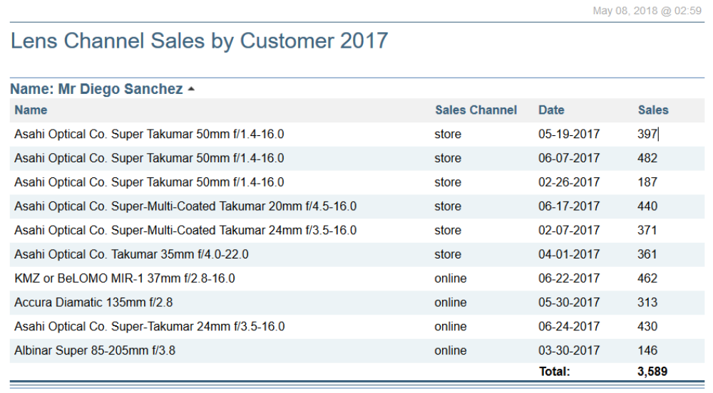
Figure 1 Current Sample Channel Sales Report

Data Analysts need to be empowered to 'slice and dice' the data on an ad-hoc basis, i.e. by time,
geography, or lens type.

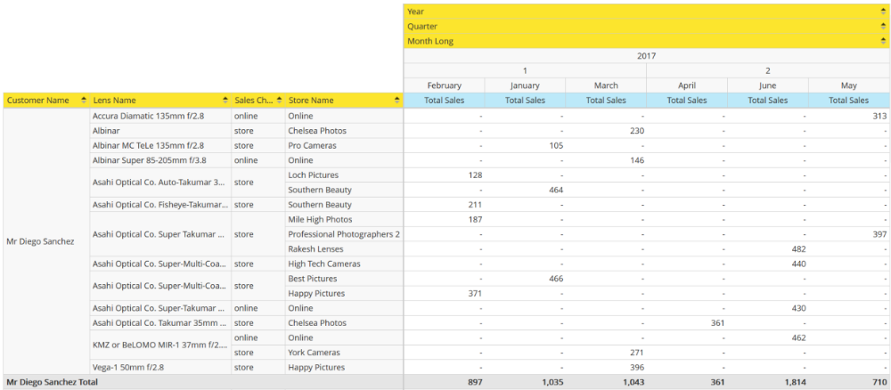
Figure 2 Manually Created Excel Reports for Data Analysts

Proposed Solution

The proposed solution will split into 2 phases.

Phase 1 Deliverables

Phase 1 Deliverables

Phase 2 Deliverables

System Architecture

Software Architecture

Assumptions & Constraints

Appendix

Please see or clink the following link for the datasheets.

Sigfox Humidity Sensor Sensirion Humidity Sensors SHT3x Datasheet.pdf
Sigfox Humidity Sensor AirWits Datasheet.pdf
Bodyworn & PTT BWC System Datasheet.pdf
Workstation Monitor Samsung S22E450DW Datasheet.pdf
Videowall TV Samsung UD46E Datasheet.pdf
Videowall KVM Aten KVM Datasheet.pdf
Videowall Digital Matrix Processor Extron DMP Datasheet.pdf
Videowall IP Link Pro Controller Processor Extron IPCP Datasheet.pdf

References

Cisco DX80 https://www.cisco.com/c/en/us/products/collaboration-endpoints/dx80/index.html
Cisco Smart Room Kit https://www.cisco.com/c/en/us/products/collateral/collaboration-endpoints/spark-room-kit-series/datasheet-c78-738729.html
SigFox https://www.sigfox.com/en/sigfox-iot-technology-overview

